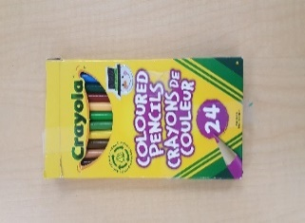
Kindergarten Supply List
- 24 pack of pencil crayons
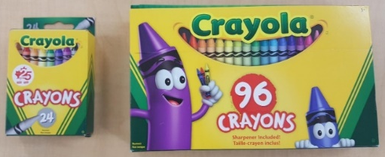
- 16 or 24 pack of crayons (nothing larger)

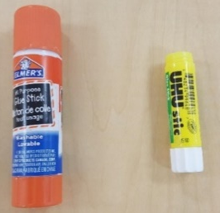
- 4 large Elmer glue sticks (small ones don’t last very long)

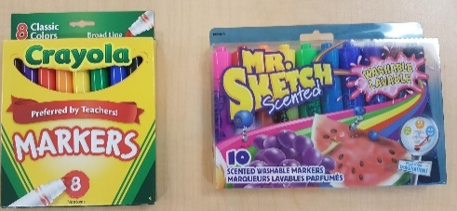
- 8 pack of markers (nothing larger, or anything fancy)

- Velcro shoes (PLEASE NO LACES)
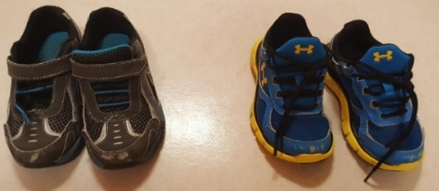

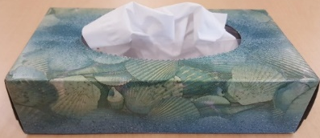
- 2 Kleenex boxes

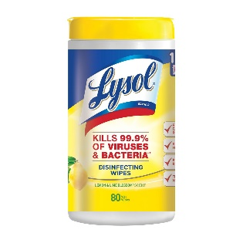
- 1 container of Lysol wipes

- 1 plastic pencil box
